Real Rail Adventures: Swiss Grand Tour
with Jeff Wilson

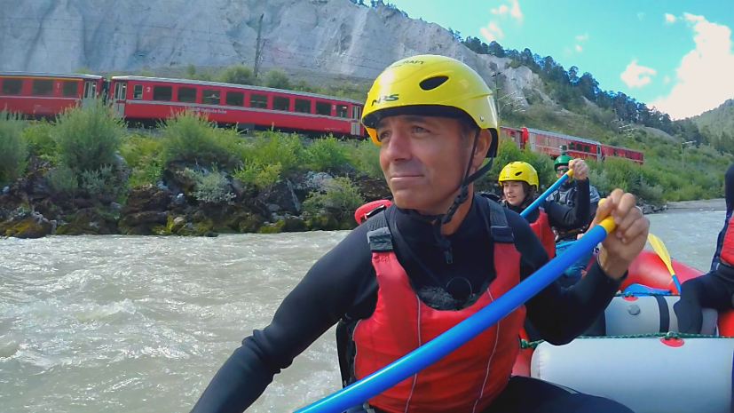
Real Rail Adventures: Swiss Grand Tour host Jeff Wilson is looking for outdoor excitement in Switzerland aboard the world’s best rail system. Wilson is following the official “Grand Train Tour of Switzerland”, eight train lines that circumnavigate the country. According to Jeff, “you can pick up the Grand Train Tour at any point and choose any travel direction.” Jeff is on track for open-air fun: He whisks down whitewater rapids in the “Swiss Grand Canyon,” pedals the luminous shore of Lake Constance, kayaks serene Lake Trübsee, and climbs the Mt. Titlis Ridge Walk to a perilous suspension bridge. Then Jeff hops back on the train for an elegant lunch in a vintage dining car and even more adventure hiking the Railway Adventure Trail from Preda to Bergün.

Real Rail Adventures: Swiss Grand Tour destinations include: Schaffhausen, Rhein Fall, St. Gallen, Appenzell, Martigny, Engelberg and more. Featured rail lines include: Albula-Bernina Railway, the Glacier Express, The Appenzeller Bahn, The Kambly Cookie Train and more. Real Rail Adventures: Swiss Grand Tour is co-produced by Small World Productions and KCTS/Seattle and is distributed
nationally in the U.S. by American Public Television Exchange.

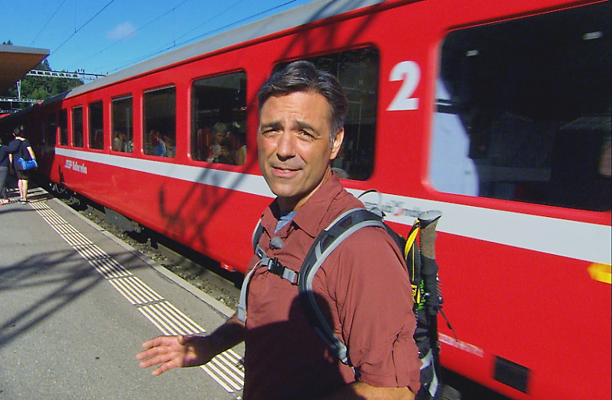
Jeff Wilson, host of Real Rail Adventures: Swiss Grand Tour prepares to board the Bernina Express, one of eight lines that comprise the “Grand Train Tour of Switzerland.” In the second episode of this Telly Award winning series, Jeff’s adventures continue with another set of train, different destinations, and additional Swiss splendors. Viewers’ choices are expanded as well with more Swiss trains—new and old, big and small, breathtaking and efficient.

Incomparable recreation options are featured too in Real Rail Adventures: Swiss Grand Tour. Jeff models how-to take Swiss trains to scenic hikes, exhilarating bike rides and outdoor hot spots. Lively locals along the way provide context, insights and diversity. Short stopovers reveal remarkable panoramas, daily traditions, and irresistible strolls in pristine villages.

From world-class main-lines to stunning scenic routes, Real Rail Adventures: Swiss Grand Tour celebrates triumphs of Swiss engineering that have created a state-of-the art system crisscrossing the country’s unbelievably challenging terrain. Co-produced by Small World Productions and KCTS/Seattle, Real Rail Adventures:
Swiss Grand is distributed nationally in the U.S. by APT Exchange.

Photos and press kit documents may be downloaded from www.RealRailTV.com
| Travel Apparel Provided by Columbia Sportswear| www.Columbia.com |

