Real Rail Adventures: Swiss Grand Tour
PRESS RELEASE

Real Rail Adventures: Swiss Grand Tour a new one-hour special from American Public Television, will air on _________ (station) _________________ at (time) _______, (day) __________ (date) _________. Hosted by Jeff Wilson, this episode features the Grand Train Tour of Switzerland and is the sequel to a Telly Award-winning documentary co-produced by Small World Productions and KCTS/Seattle. The adventures continue with another set of rides, different destinations, and more Swiss splendors. Viewers’ choices are expanded with Swiss trains aplenty—new and old, big and small, breathtaking and efficient.

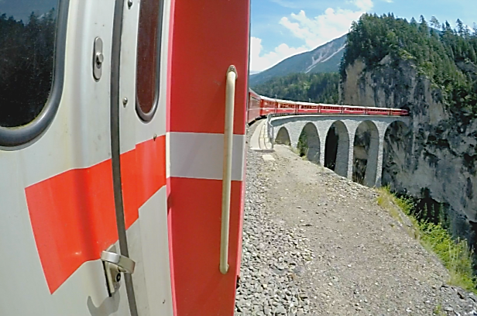
Incomparable recreation options are featured too in Real Rail Adventures: Swiss Grand Tour. Host Jeff Wilson models how-to take Swiss trains to scenic hikes, exhilarating bike rides and outdoor hot spots. Lively locals along the way provide context, insights and diversity. Short stopovers reveal remarkable panoramas, daily traditions, and irresistible strolls in pristine villages.

First, Jeff heads north from Zurich on the SBB line and stops in historic Schaffhausen on the Rhein River. With traditional brown-roofed houses and extravagantly painted facades, the city looks as if it’s waiting for a medieval merchant to pull into town.

Schaffhausen’s emblem, the Munot fortress, was built nearly 500 years ago. A hike to mighty Rheinfall, Europe’s largest waterfall near Schaffhausen, and a rope park with crazy obstacles and swooping zip-lines provide heady adventure for Jeff.

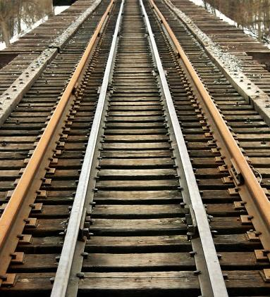
Next a leisurely cruise on a Rhine River boat lands Jeff in Stein am Rhein for a wander back in time. A conclave of half-timbered houses huddled together, Stein-am-Rhein, looks like a set from a costume drama. It’s Europe’s best preserved medieval village.

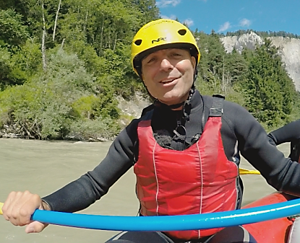
Aboard the SBB line again, an hour train ride leads to St. Gallen and the city's Abbey Precinct, a UNESCO World Heritage site with its landmark cathedral and a baroque library. Nearby, the region of Appenzellerland transforms from rolling hills to sheer Alps. Jeff whisks up Ebenalp to Wildkirchli, three dark mountain caverns where ancient cave bears and Neanderthals once found refuge, and later Christian monks built a hermitage and chapel.

Departing St. Gallen, Jeff relaxes on board the train as the softer side of Switzerland scrolls by—gentle undulating hills, picture-perfect villages, and mellow orchards.

After an elegant lunch in a vintage dining car reminiscent of the 1930’s, Jeff heads for more outdoor adventures: hiking “the train experience trail" along the Bernina Line near Preda, and pulse-pounding white-water rafting on the Vorderrhein River descending through the “Swiss Grand Canyon.”
Real Rail Adventures: Swiss Grand Tour

Heading south again, the Glacier Express leads to Martigny. Blessed with the warm Valais sunshine and surrounded by vineyards and orchards, Martigny’s history stretches back two thousand years: Celtic tribes, the Romans and Napoleon's troupes have all left traces here. The Giannada Museum provides glimpses of the past and an art collection that includes works by Picasso and Matisse. Nearby, the St. Bernard Museum serves-up heartwarming stories of Alpine rescues by the famous breed of dogs. For pure fun, Jeff joins a trainer for a walk with several resident St. Bernards and delights in petting a litter of puppies.

More outdoor adventures await as Jeff turns north again. Near the Alpine village of Engelberg, he immerses in quiet serenity, kayaking the clear glacial waters of Lake Trübsee beneath sheer mountain walls. Then Jeff boards the sleek Titlis Rotair gondola to the top and a hair-raising cliff walk over a scenic foot bridge.

Once again in Real Rail Adventures: Swiss Grand Tour, HD images from Emmy Award winning photographers will sweep viewers into virtual adventures aboard the world’s best rail system. Amazing trains, scenic grandeur, historic perspective and concise travel advice mesh seamlessly in RRA—Swiss Grand Tour.

Real Rail Adventures: Swiss Grand Tour will again showcase the construction marvels and visual splendors of the Swiss rail system. From world-class mainlines, to stunning scenic routes, to pioneering steam locomotives and historic cog trains, we celebrate triumphs of Swiss engineering and ingenuity. Soaring peaks and plunging valleys pose mind-boggling obstacles for trains. The Swiss have responded with astonishing trestles, bridges and tunnels.

Real Rail Adventures: Swiss Grand Tour will enchant. We’re packed and ready to go. Join us for a new Swiss adventure!

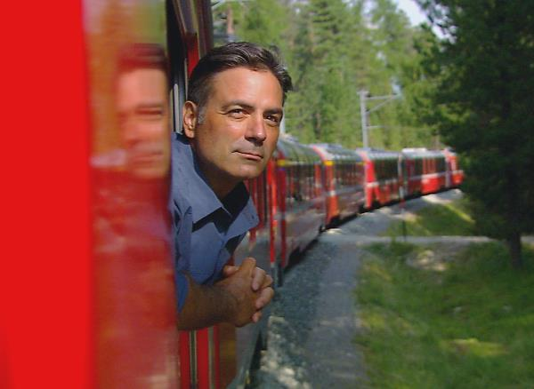
Host Jeff Wilson, a lifelong train aficionado, is charismatic, energetic, and filled with a passion for travel. A proven on-camera communicator, Jeff has hosted ‘how-to’ TV programs for more than a decade. Warm, easygoing and curious, Jeff is an ideal virtual travel companion. Along with Small World’s award-winning producers and writers Jeff packs Real Rail Adventures with information and context—key destinations, relevant history, and up-to-date advice. He models how to create an authentic, memorable, and personal rail adventure through first-person
experiences. Jeff engages with real
people along his journey to help viewers better understand and appreciate Switzerland and its storied culture.

Real Rail Adventures: Swiss Grand Tour
Real Rail Adventures DVDs with two complete programs on Swiss trains are available from Small World Productions. Each DVD contains value-added bonuses including never-before-seen footage, and behind-the-scenes glimpses. DVDs are $24.95 each plus shipping. Viewers may order online at www.RealRailTV.com or they may call the order desk at 800.866.7425.

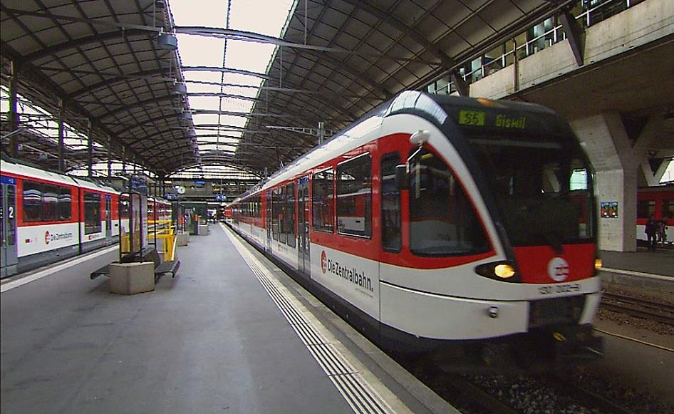
Real Rail Adventures: Swiss Grand Tour will be up-linked on APT’s HD satellite transponder. HD and standard definition “letterboxed” versions of the documentary will air on hundreds of public TV stations nationwide. Digital audio is transmitted in stereo.

American Public Television (APT) has been a leading distributor of high-quality, top-rated programming to the nation’s public television stations since 1961. In 2014, APT distributed one-third of the top 100 highest-rated public television titles in the U. S. Among its 300 new program titles per year, APT programs include prominent documentaries, news and current affairs programs, dramas, how-to programs, children’s series and classic movies. America’s Test Kitchen From Cook’s Illustrated, Rick Steves’ Europe, Live From the Artists Den, Doc Martin, Nightly Business Report, Midsomer Murders, Vera, NHK Newsline, Lidia’s Kitchen, Globe Trekker, Simply Ming, and P. Allen Smith’s Garden Home join numerous documentaries and performance programs popular with public television viewers. APT licenses programs internationally through its APT Worldwide service. Now in its 10th year, Create® TV — featuring the best of public television's lifestyle programming — is distributed by APT. APT also distributes WORLD™, public television’s premier news, science and documentary channel. To find out more about APT’s programs and services, visit APTonline.org.

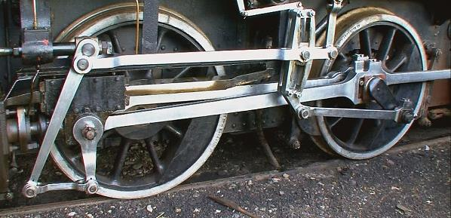
| Jeff Wilson’s Travel Apparel Provided by: ColumbiaSportswear|www.Columbia.com |

